IoT Real World Programmable Blocks


A Project Submitted in Partial Fulfillment of the Requirements for the Degree of Bachelor of Science in Computer Science and Engineering
Under National University

Submitted By
Md. Antor Ahmed
Reg. No: | 16502000527
Session: | 2016-17

DEPARTMENT OF COMPUTER SCIENCE AND ENGINEERING
NATIONAL UNIVERSITY, DHAKA, BANGLADESH

September 2022

APPROVAL
The project is titled “IoT Real World Programmable Blocks” submitted by Reg No: 16502000527 to the development of Computer Science and Engineering. Dhaka City College, Dhaka, Bangladesh has been accepted as satisfactory for partial fulfillment of the required studio style and content for a Bachelor’s Degree in Computer Science and Engineering.

Signature of Internal Signature of External
Examiner Examiner

Supervisor Head of the Department
Md. Shahiduzzaman Md. Mustafa Kamal
Assistant Professor Associate Professor
Department of CSE Department of CSE
Dhaka City College Dhaka City College

DECLARATION
I hereby, declare that the work presented in this project “IoT Real World Programmable Blocks” is the outcome of the investigation performed by use under the supervision of Md. Shahiduzzaman, Assistant Professor, CSE Department, Dhaka City College, Dhaka, Bangladesh. We also declare that no part of this project and thereof has been or is being submitted elsewhere for the award of any degree or diploma.

Supervised by:
Md. Shahiduzzaman
Assistant Professor
Department of Computer Science and Engineering
Dhaka City College

Submitted by:
Md. Antor Ahmed
Reg. No.: 16502000527

ABSTRACT
This thesis presents an Internet of Things (IoT) programmable block that combines an ESP8266-based Wemos D1 mini controller with sensor and actuator interfaces. The hardware design includes a DHT11 temperature and humidity sensor, a motion-sensor connector, a push button, an LED indicator and a transistor-driven buzzer. A revised schematic and printed circuit board integrate these interfaces into a compact programmable node. The web platform provides a React and React Flow visual designer, a PHP JSON API for device state, and Python automation scripts generated from visual workflows. An AI chatbot on the website can create or revise an automation script and apply the corresponding changes to the visual designer as an agent. The prototype demonstrates an end-to-end approach to configuring connected hardware through both visual and natural-language interaction.

ACKNOWLEDGEMENTS

All praises are for the almighty Allah for giving us strength, without which I could not afford to attempt this research work.
I would like to express my sincere and heartiest gratitude to my honorable thesis supervisor Md. Shahiduzzaman, Assistant Professor, Dept. of Computer Science and Engineering, Dhaka City College, for his continuous motivation, guidance and keen encouragement, which helped me throughout the time of my research work. Noting is comparable to his keen advice.
I would like to think all the members of the board examiner for their precious time in understanding my work and their insightful comment. I would like to thank all of my friends for their co-operation. Finally, yet importantly, I am grateful to my parents for their continuous support and co-operation.
I also express our sincere thanks and gratitude to Prof. Bedar Uddin Ahmed (Principal) and Md. Mustafa Kamal (Head of the Department) for their support and guidance and constant encouragement for completion of project report.
I also thankful to other respected teachers of the department, who helped me in a number of ways by providing various resources and moral support.
Any omission in this brief acknowledgment does not mean lack of gratitude.

Table of Contents
APPROVAL ii
DECLARATION iii
ABSTRACT iv
ACKNOWLEDGEMENTS v
Table of Contents vi
List of Figures viii
List of Tables: ix
Chapter 1 10
Introduction 10
1.1 Introduction 11
1.2 Motivation for the work 11
1.3 Project Objectives 11
1.4 Project Goals 12
1.5 Application technology 12
1.6 Application server 12
Chapter 2 14
Components of Project 14
2.1 ESP8266-12E 15
2.2 AMS1117 3.3V 18
2.3 DHT11 – Humidity 19
2.4 LED 19
2.5 Resistor (1K, 220ohm) 21
2.6 Buzzer 23
2.7 Power Supply 24
2.8 Battery 25
2.9 TP4056 26
2.10 Transistor (BC547) 28
Chapter 3 30
Requirements & Analysis 30
3.1 Problem Statement 31
3.2 Drawbacks of Existing System 31
3.3 Methodology 32
3.4 Projects features 32
3.5 Some Applications of this project: 32
Chapter 4 33
Design 33
4.1 System Architectural Design 34
4.2 Circuit Schematic Design 35
4.3 E-R Diagram 36
Chapter 5 38
Implementation 38
5.1 Introduction 39
5.2 PCB Design 39
5.3 3D Modelling 41
5.4 Circuit Board Assemble 44
5.5 Future Works 48
Appendix 52
Server Code 52
Python Module 53
ESP8266 Firmware Source Code 55
Conclusion 57
References 58

List of Figures
Figure 2.1 Wemos D1 mini (ESP8266)15
Figure 2.3 DHT11 19
Figure 2.4 LED 20
Figure 2.5 Working of LED 20
Figure 2.6 Resistor 21
Figure 2.7 Resistor in parallel 22
Figure 2.8 Resistor in series 22
Figure 2.9 Buzzer 23
Figure 2.10 Buzzer pinout 23
Figure 2.11 Buzzer working principle 24
Figure 2.12 DC power supply 24
Figure 2.13 Battery 25
Figure 2.14 Battery Discharge profile 26
Figure 2.16 BC547 28
Figure 2.17 Transistor Symbol 29
Figure 4.1 System Architecture34
Figure 4.2 Previous schematic (superseded)35
Figure 5.1 PCB layout, revision 27 September 202640
Figure 5.2 3D Model Top View 41
Figure 5.3 3D model Side View 42
Figure 5.4 3D Model Side View 2 42
Figure 5.5 3D Model Inside View 1 43
Figure 5.6 3D Model Inside View 2 43
Figure 5.7 3D Model Inside Top View 44
Figure 5.8 Implemented Block - Relay 45
Figure 5.9 Implemented Block – Buzzer 46
Figure 5.10 Implemented Block - Temperature 46
Figure 5.11 Implemented Block - Button or LED 47
Figure 5.12 Implemented Block - Outside 47
Figure 5.13 Implemented Block - Side View 48

List of Tables:

Table 2.1 ESP8266 Pinout 15

Chapter 1

Introduction

Chapter 1
Introduction

1.1 Introduction

This project develops an IoT programmable block that connects physical inputs and outputs to a web-based automation environment. A Wemos D1 mini based on the ESP8266 provides Wi-Fi connectivity and controls the block interfaces. Users can assemble workflows in the React visual designer, run the generated Python automation, and use the website chatbot to create or revise a workflow and its script.

1.2 Motivation for the work

Configuring IoT devices often requires separate knowledge of electronics, firmware, APIs and automation code. This project brings those steps together: a compact hardware block exposes sensor and actuator state, a visual designer represents automation as connected blocks, and an AI chatbot can translate a natural-language request into script and designer updates. The intent is to lower the effort required to prototype and revise device behaviour while keeping the resulting workflow visible for inspection.

1.3 Project Objectives

- Design an ESP8266-based programmable block with the sensor and actuator interfaces shown in the updated circuit schematic.
- Connect the block to Wi-Fi and exchange device state through an HTTP API.
- Provide a React-based visual designer for creating and editing connected automation flows.
- Generate Python automation scripts from the visual workflow.
- Provide a website AI chatbot that can write or revise scripts and apply the matching changes to the visual designer.
- Update the circuit and PCB documentation to reflect the current hardware revision.

1.4 Project Goals

- Make common sensor-to-actuator automations configurable without requiring users to write every rule by hand.
- Keep visual flows, generated scripts, device state and physical I/O connected through documented interfaces.
- Support iterative prototyping through a compact ESP8266 block and a revision-controlled schematic and PCB layout.

1.5 Application technology

The browser application is implemented in React and uses React Flow to display and connect input, sensor, logic and actuator blocks. Its inspector exposes block settings and flow warnings alongside the generated Python script. An AI chatbot on the website can create or update the script and apply the related changes to the visual flow.
The device service is a PHP HTTP API that exchanges JSON state. In the checked-in implementation, device records are persisted as per-device JSON files rather than a MySQL database. The ESP8266 firmware is written in C++ for the Arduino framework, while automation logic is represented and executed as Python.

1.6 Application server

The system is implemented as a web application, API, automation runtime and embedded device rather than as a single server program.

- Embedded firmware: PlatformIO with the Arduino framework is used to build and upload the ESP8266 firmware.
Web designer: React and React Flow provide the canvas, block inspector, flow validation and generated-script view.

- Device API: PHP exposes HTTP endpoints for device discovery and reading or updating device state.
Automation: Python scripts poll sensor and device state and issue API updates to control outputs.

- AI agent: the website chatbot interprets a user request, writes or edits the automation script and updates the visual designer flow.
Hardware: the schematic and PCB CAD tools are used to document and route the programmable block; the updated board export is dated 27 September 2026.

Chapter 2

Components of Project

Chapter 2
Components of Project

2.1 Wemos D1 mini (ESP8266)

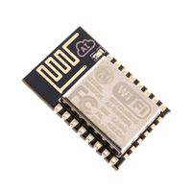
Figure 2.1 Wemos D1 mini (ESP8266)
The current controller is a Wemos D1 mini built around the ESP8266. It provides Wi-Fi connectivity and digital I/O for the programmable block. The firmware configures D1 for the button, D5 for the temperature sensor, D6 for the external LED and D7 for the buzzer; the board also uses the module onboard LED for connection status.

2.1.1 Pin Configuration
The ESP-12E module has twenty-two pins and we will describe function of each pin below.
Table 2.1 ESP8266 Pinout
Pin | Name | Description
1 | RST | Reset Pin of the module
2 | ADC | Analog Input Pin for 10-bit ADC (0V to1V)
3 | EN | Module Enable Pin (Active HIGH)
4 | GPIO16 | General Purpose Input Output Pin 16
5 | GPIO14 | General Purpose Input Output Pin 14
6 | GPIO12 | General Purpose Input Output Pin 12
7 | GPIO13 | General Purpose Input Output Pin 13
8 | VDD | +3.3V Power Input
9 | CS0 | Chip selection Pin of SPI interface
10 | MISO | MISO Pin of SPI interface
11 | GPIO9 | General Purpose Input Output Pin 9
12 | GPIO10 | General Purpose Input Output Pin 10
13 | MOSI | MOSI Pin of SPI interface
14 | SCLK | Clock Pin of SPI interface
15 | GND | Ground Pin
16 | GPIO15 | General Purpose Input Output Pin 15
17 | GPIO2 | General Purpose Input Output Pin 2
18 | GPIO0 | General Purpose Input Output Pin 0
19 | GPIO4 | General Purpose Input Output Pin 4
20 | GPIO5 | General Purpose Input Output Pin 5
21 | RXD0 | UART0 RXD Pin
22 | TXD0 | UART0 TXD Pin

2.1.2 Features and Electrical Characteristics
- Wireless Standard: IEEE 802.11 b/g/n protocol
- Frequency Range: 2.412 - 2.484 GHz
- Serial Transmission: 110 - 921600 bps, TCP Client 5
- SDIO 2.0, SPI and UART Interface available
- PWM available
- One ADC channel available
- Programmable GPIO available
- Wireless Network Type: STA / AP / STA + AP
- Security Type: WEP / WPA-PSK / WPA2-PSK
- Encryption Type: WEP64 / WEP128 / TKIP / AES
- Network Protocol: IPv4, TCP / UDP / FTP / HTTP
- Operating Voltage: 3.3V
- Maximum current allowed to draw per pin: 15mA
- Power down leakage current of < 10uA
- Integrated low power 32-bit MCU
- Onboard PCB Antenna
- Wake up and transmit packets in < 2ms
- Standby power consumption of < 1.0mW
- Operating Temperature: -40ºC to +125 ºC

2.1.3 Overview of ESP-12E

ESP-12E is a member of ‘ESP-XX’ series. Although all of them are based on ESP8266 SoC they differ in on output pins, flash memory and antenna type. These modules numbered from ESP-01 to ESP-15 and are best in performance and cost. Many engineers use these modules to setup a wireless communication between two applications. For data sharing and IoT you will find these modules Ideal.

2.1.4 How to use the ESP-12E
This module does not have complex circuitry or programming so using this module is very easy. We will construct a simple application circuit for understanding the module working.
Steps for setting up a simple application circuit:
- Connect positive +3.3V power to the module.
- Interface module to a microcontroller or ARDUINO using UART (Connect RXD of ESP to RXD of µC & TXD of ESP to TXD of µC).
- Download the libraries for the module from the internet. For ARDUINO, the IDE will have pre-installed libraries. If you do not have them just update the libraries from ARDUINO website.
- Write the program for setting up the baud rate and data exchange.
- Send data to the module for transmitting through Wi-Fi or Receive data from the module that was transmitted via Wi-Fi.
- There is another way for setting up the module which is to bypass microcontroller and directly connect the module to PC using FTDI. After interface you can use serial monitor to communicate with the module.

2.2 Motion Sensor Interface

The revised schematic provides a three-pin motion-sensor connector for an external sensor module. The connector brings the sensor supply, ground and signal into the programmable block; the motion event can then be represented as an input to an automation flow.

2.3 DHT11 – Humidity
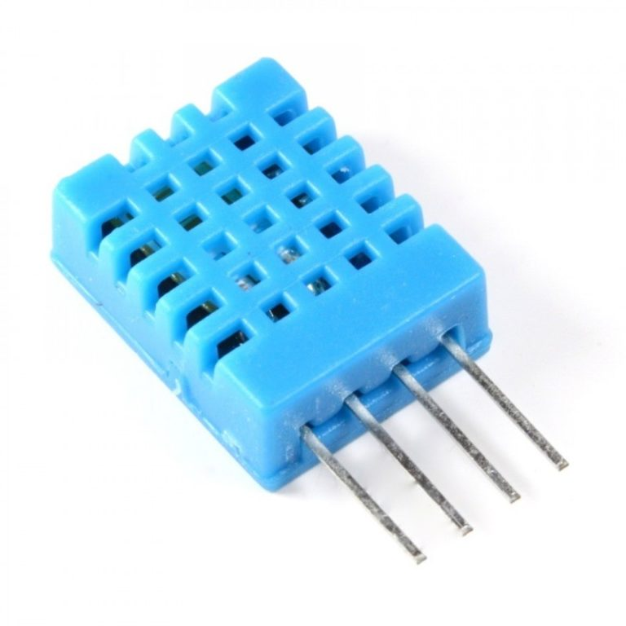
Figure 2.3 DHT11
The DHT11 provides temperature and relative-humidity measurements over a digital data connection and is present in the revised schematic. The checked-in firmware instead configures a one-wire temperature sensor on D5, so firmware compatibility with the DHT11 remains to be verified.

2.4 LED

The LED is a PN-junction diode which emits light when an electric current passes through it in the forward direction. In the LED, the recombination of charge carrier takes place. The electron from the N-side and the hole from the P-side are combined and gives the energy in the form of heat and light. The LED is made of semiconductor material which is colorless, and the light is radiated through the junction of the diode.

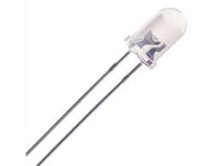
Figure 2.4 LED
The LEDs are extensively used in segmental and dot matrix displays of numeric and alphanumeric character. The several LEDs are used for making the single line segment while for making the decimal point single LED is used.

2.4.1 Working of LED

The working of the LED depends on the quantum theory. The quantum theory states that when the energy of electrons decreases from the higher level to lower level, it emits energy in the form of photons. The energy of the photons is equal to the gap between the higher and lower level.
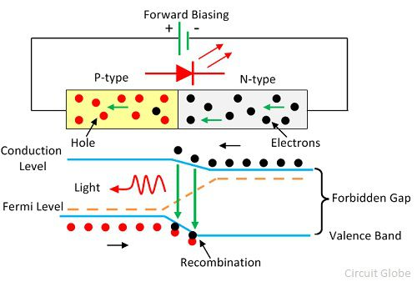
Figure 2.5 Working of LED

The LED is connected in the forward biased, which allows the current to flows in the forward direction. The flow of current is because of the movement of electrons in the opposite direction. The recombination shows that the electrons move from the conduction band to valence band and they emit electromagnetic energy in the form of photons. The energy of photons is equal to the gap between the valence and the conduction band.

2.5 Resistors (100 ohm and 4.7 kohm)

The revised circuit uses a 100-ohm series resistor with the indicator LED and a 4.7-kohm resistor in the buzzer transistor drive path. These resistors limit LED current and provide base drive for the BC547 switching transistor, respectively.
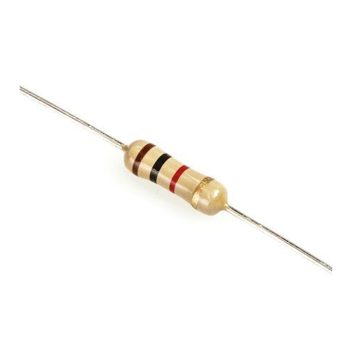
Figure 2.6 Resistor
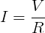

2.5.1 Resistors in parallel:
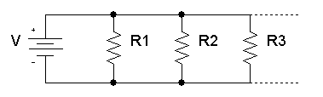
Figure 2.7 Resistor in parallel

The total equivalent resistance of resistors in parallel R_{Total} is given by:
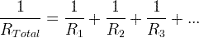

So, when you add resistors in parallel, the total resistance is decreased.

2.5.2 Resistors in series:
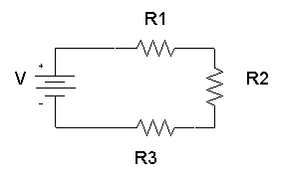
Figure 2.8 Resistor in series

The total equivalent resistance of resistors in series R_{total} is the sum of the resistance values:
R_{total} = R₁+ R₂+ R₃+...

In this project we are using 1kilo-ohm resistor for Buzzer and 220ohm resistor for LED.

2.6 Buzzer

The buzzer provides an audible indication controlled by the ESP8266. In the updated schematic it is switched through a BC547 NPN transistor, with a 4.7-kohm base resistor between the controller signal and transistor base.
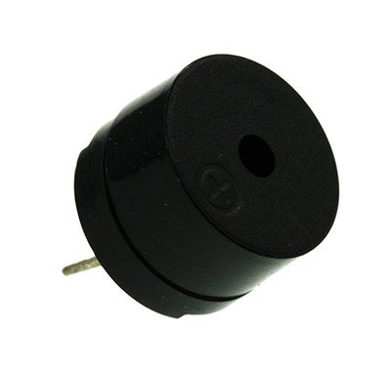
Figure 2.9 Buzzer

2.6.1 Working Principle of Buzzer

Because active buzzer has integrated amplify sampling circuit and resonance system, when DC power input passes through active buzzer, it will make resonance device generate sound signal. We can see the schematic diagram below for the working principle of active buzzer:
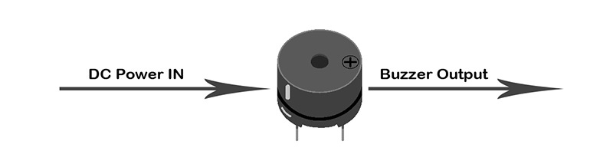
Figure 2.10 Buzzer pinout
When square wave signal passes through the buzzer, its resonance device will transform the square wave signal input into sound signal output. Below is the schematic diagram for the working principle of passive buzzer:
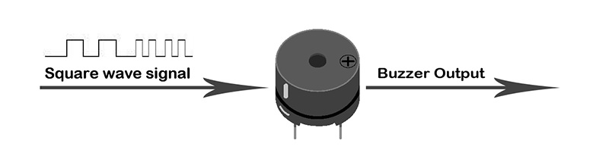
Figure 2.11 Buzzer working principle
In this Project we are using active Buzzer.

2.7 Power Supply

The schematic distributes the supply and ground rails to the controller and peripheral connectors. The power interface is shown with VCC, GND, OUT+, OUT-, B+ and B- terminals; the exact battery chemistry and charging characteristics must follow the selected power module datasheet.
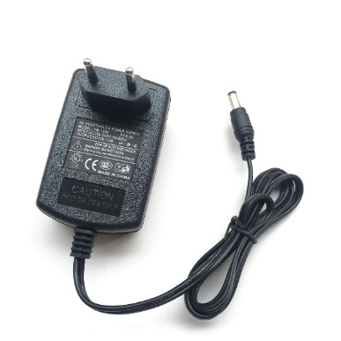
Figure 2.12 DC power supply

2.8 Battery

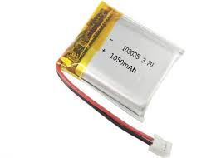
Depending on the design and chemistry of your lithium cell, you may see them sold under different nominal "voltages". For example, almost all lithium polymer batteries are 3.7V or 4.2V batteries. What this means is that the maximum voltage of the cell is 4.2v and that the "nominal" (average) voltage is 3.7V. As the battery is used, the voltage will drop lower and lower until the minimum which is around 3.0V. You should see the number 3.7V written on the battery itself somewhere.
Figure 2.13 Battery
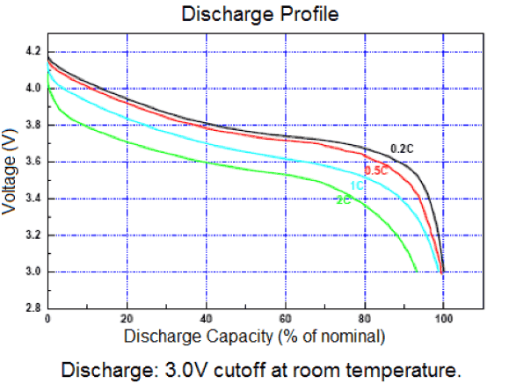
For example, here is a profile of the voltage for a 'classic' 3.7V/4.2V battery. The voltage starts at 4.2 maximum and quickly drops down to about 3.7V for the majority of the battery life. Once you hit 3.4V the battery is dead and at 3.0V the cutoff circuitry disconnects the battery (more on that later.
Figure 2.14 Battery Discharge profile
The battery connection is part of the board power interface. The schematic labels separate battery terminals (B+ and B-) from the module output terminals (OUT+ and OUT-); no cell capacity or chemistry is assumed by this thesis.

2.9 Power Module Interface

The updated schematic represents the power module by its VCC, GND, battery and output terminals. These labels describe the connections available to the board and do not, by themselves, identify a specific charger IC or protection circuit.

2.9.1 FEATURES:

- Programmable Charge Current Up to 1000mA
- No MOSFET, Sense Resistor or Blocking Diode Required
- Complete Linear Charger in SOP-8
- Package for Single Cell Lithium-Ion Batteries
- Constant-Current/Constant-Voltage
- Charges Single Cell Li-Ion Batteries Directly from USB Port
- Preset 4.2V Charge Voltage with 1.5% Accuracy
- Automatic Recharge
- Two Charge Status Output Pins
- C/10 Charge Termination
- 2.9V Trickle Charge Threshold (TP4056)
- Soft-Start Limits Inrush Current
- Available Radiator in 8-Lead SOP Package, the Radiator need connect GND or impending

2.10 Transistor (BC547)

The BC547 is an NPN transistor used as a low-side switch for the buzzer. The ESP8266 drives its base through a 4.7-kohm resistor, allowing the GPIO to control the buzzer without supplying its load current directly.
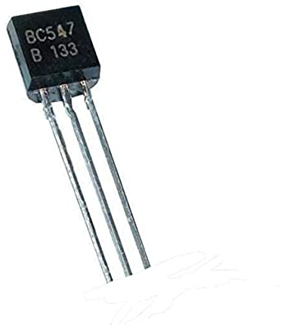
The transistor consists two PN diode connected back-to-back. It has three terminals namely emitter, base and collector. The base is the middle section which is made up of thin layers. The right part of the diode is called emitter diode and the left part is called collector-base diode. These names are given as per the common terminal of the transistor. The emitter-based junction of the transistor is connected to forward biased and the collector-base junction is connected in reverse bias which offers a high resistance.
Figure 2.16 BC547
The transistor has collector, base and emitter terminals. In this circuit the buzzer is connected in the collector switching path and the emitter returns to ground; the exact current and voltage limits must remain within the BC547 and buzzer ratings.
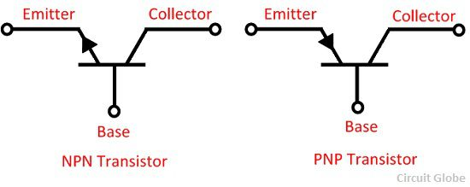
The arrow in the symbol indicates the direction of flow of conventional current in the emitter with forward biasing applied to the emitter-base junction. The only difference between the NPN and PNP transistor is in the direction of the current.
Figure 2.17 Transistor Symbol

Chapter 3

Requirements & Analysis

Chapter 3
Requirements & Analysis

3.1 Problem Statement
Many IoT prototypes require users to move between circuit design, embedded programming, server APIs and automation tools. That separation makes simple sensor-to-actuator behaviour difficult to create, understand and revise, especially for users who are learning programming.
- The project addresses usability by pairing a physical ESP8266 programmable block with a browser-based visual designer and generated Python automation.
- The system must keep device state and automation changes synchronized across the web interface, PHP API, Python runtime and hardware.
- AI-generated changes also need to remain visible in the designer so users can inspect the resulting logic rather than receiving an opaque script alone.

3.1.1 Existing Systems

- IoT Smart Home [1]
- IoT in Agriculture Monitoring [6]
- Google Home Voice Controller [4]
- Amazon Dash Button
- Smart door Lock
- Air Quality Monitor

3.2 Drawbacks of Existing System

- The major problem of IoT devices they are totally independent, that’s mean each device do a specific predefined task always.
- Less configurable options.
- For multiple tasks, need multiple apps.
- Customization in device function isn’t allowed.

3.3 Methodology

- Define the hardware interfaces from the revised ESP8266 schematic and route the corresponding PCB.
- Implement firmware for Wi-Fi configuration, local I/O and device-state exchange.
- Provide a PHP HTTP API for discovering devices and reading or updating JSON state.
- Build the visual automation canvas and inspector with React and React Flow.
- Generate Python automation scripts from connected input, sensor, logic and actuator blocks.
- Integrate the website chatbot so it can write or revise the script and apply the matching flow changes.
- Review the generated flow, API behaviour and hardware connections against the documented interfaces.

3.4 Projects features

- React-based visual designer for connecting IoT input, sensor, logic and actuator blocks.
- Inspector controls for selected blocks and visible flow warnings.
- Python automation script generated from the visual flow.
- Website AI chatbot that writes or revises automation scripts.
- Agent-style chatbot updates that apply the corresponding changes to the visual designer.
- PHP JSON API for device discovery and state exchange.
- ESP8266 block with button, temperature, LED and buzzer interfaces.
- Schematic-defined DHT11 and motion-sensor interfaces for sensing workflows.
- Revised PCB layout consolidating the programmable-block connections.

3.5 Some Applications of this project:

- Automation of Train Crossing
- Automation of Traffic signals
- Automation of Agriculture
- Home Automation
- Factory/Office Automation

Chapter 4

Design

Chapter 4
Design

4.1 System Architectural Design

The system has four cooperating layers: the ESP8266 programmable block reads inputs and drives outputs; the PHP API exchanges per-device JSON state; the React/React Flow application lets users create, inspect and save automation flows; and the Python runtime executes the generated automation against the API. The website AI chatbot acts on both the generated script and the visual flow, keeping the editable representation available to the user.

ESP8266 block <-> PHP JSON API <-> React Flow designer and AI agent <-> generated Python automation
Figure 4.1 System Architecture

4.2 Circuit Schematic Design

The updated circuit is built around a Wemos D1 mini (ESP8266) and exposes a DHT11 temperature/humidity connection, a three-pin motion-sensor connector, a two-pin button, an indicator LED and a buzzer switched by a BC547 transistor. The schematic shows a 100-ohm LED resistor and a 4.7-kohm transistor base resistor. A power module is represented by VCC, GND, OUT+, OUT-, B+ and B- terminals. The power-module identity and component ratings must be confirmed against the source design and datasheets. The schematic image retained in the source report is from an earlier revision and is marked as superseded pending replacement with the supplied updated schematic export.

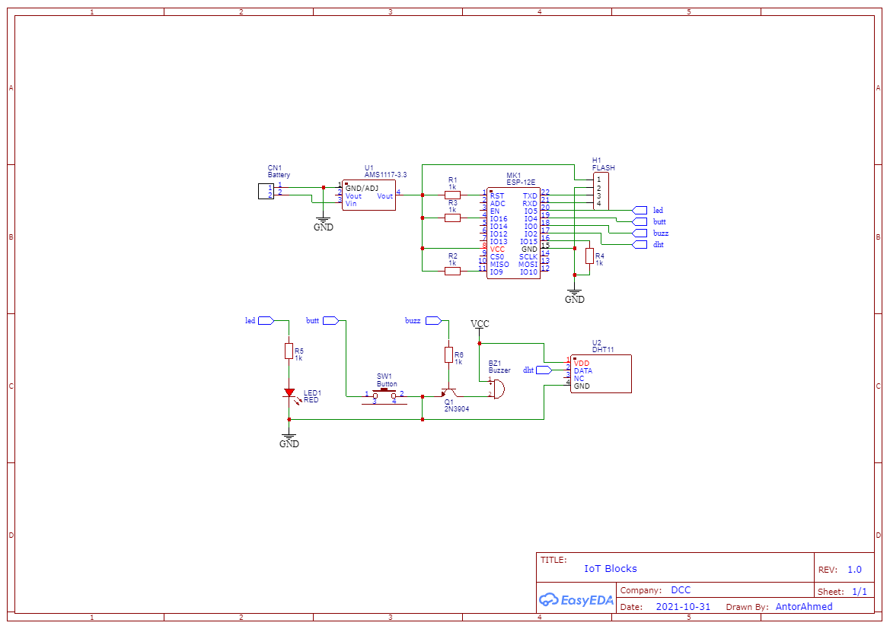
Figure 4.2 Previous schematic (superseded)

4.3 Device-State Data Model

The PHP API stores one JSON document per device. A device record includes deviceId, led, buzzer, button, tempC and updatedAt; API routes expose device listing, state reads and state updates. The deployed website may use additional storage services, but the checked-in API implementation is file-backed and does not use MySQL.

Figure 4.4 E-R Diagram

Chapter 5

Implementation

Chapter 5
Implementation

5.1 Introduction

This chapter documents the current programmable-block implementation: the updated circuit and PCB, the embedded firmware, the PHP device API, the React visual designer, the generated Python runtime and the website AI agent. The work is a prototype platform for composing and revising sensor-driven IoT automation.

5.2 PCB Design

The PCB revision dated 27 September 2026 consolidates the ESP8266 controller connections with the sensor, button, LED, buzzer-driver and power interfaces defined by the updated schematic.
The board drawing shows routed copper traces and through-hole pads for the controller and peripheral connections. Connector placement and trace routing are arranged to keep the external sensor, button and power interfaces accessible around the board.
Figure 5.1 presents the current PCB layout exported from the hardware project. The board is documented as a prototype revision; electrical rule checking, fabrication constraints and assembled-board measurements should be recorded with the final manufacturing files.
The schematic and PCB should be revised together so that connector numbering, component references, net names and board pads remain consistent.
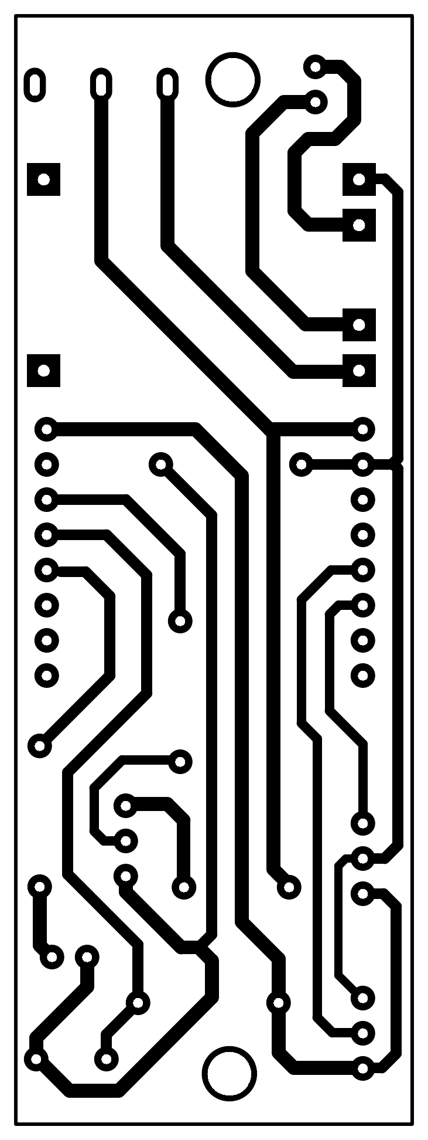

Figure 5.1 PCB layout, revision 27 September 2026

5.3 3D Modelling

A 3D model is essentially made up of vertices, which come together to form a mesh and act as the core of the 3D model. Each point on the model can be manipulated to change the shape. By using coordinate data, the software identifies the location of each vertical and horizontal point, all relative to a reference point.

The most common way to begin making a 3D model is to start with a basic shape – a cube, box, sphere, or whatever you think is best suited. From your starter shape, you can start molding and refining it into what you desire.
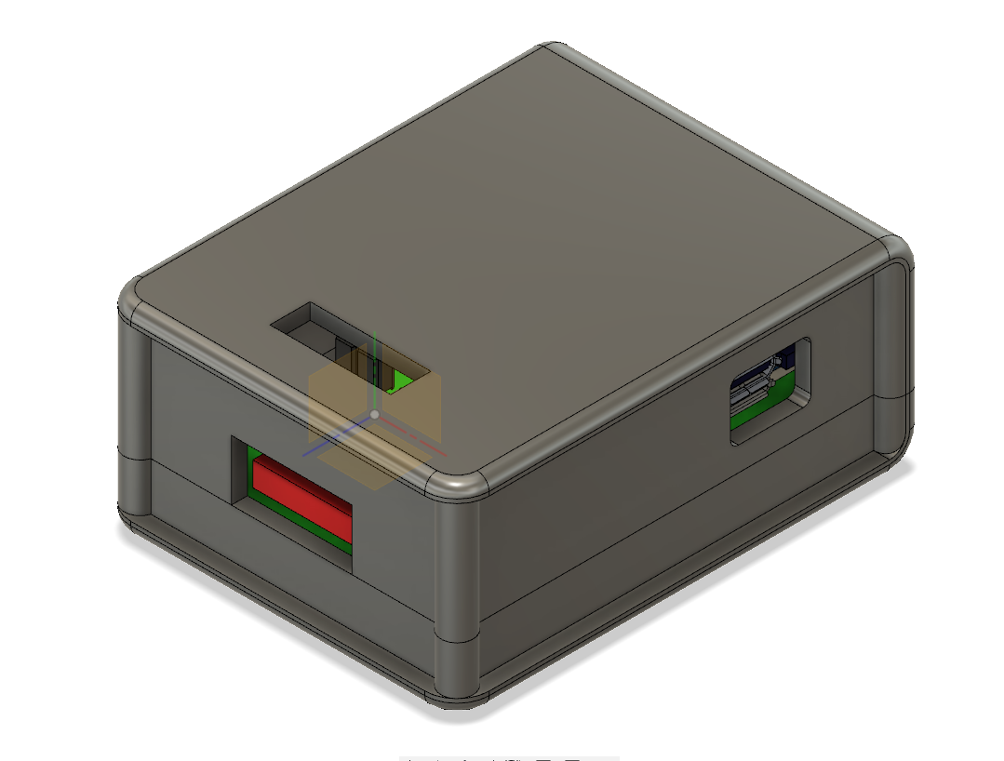
Figure 5.18 3D Model Top View
Figure 5.2 3D Model Top View
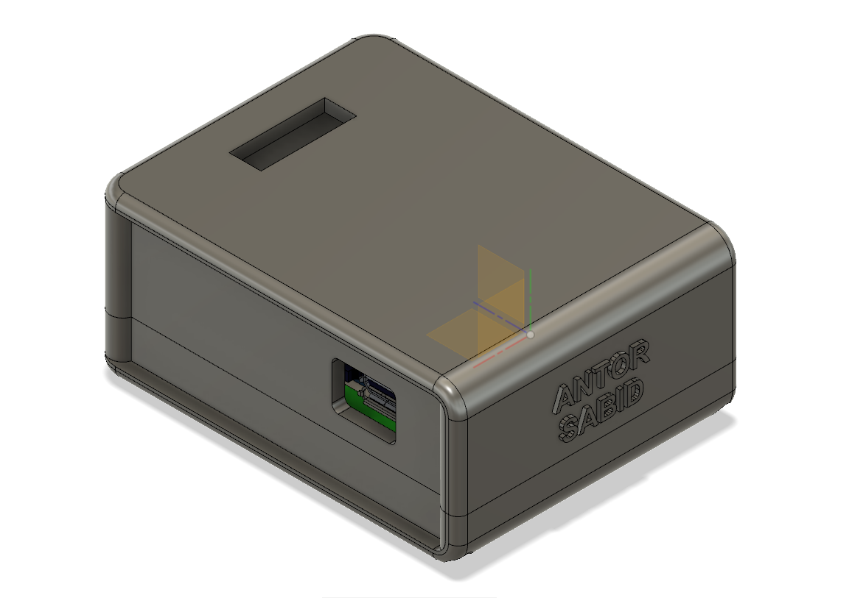
Figure 5.3 3D model Side View

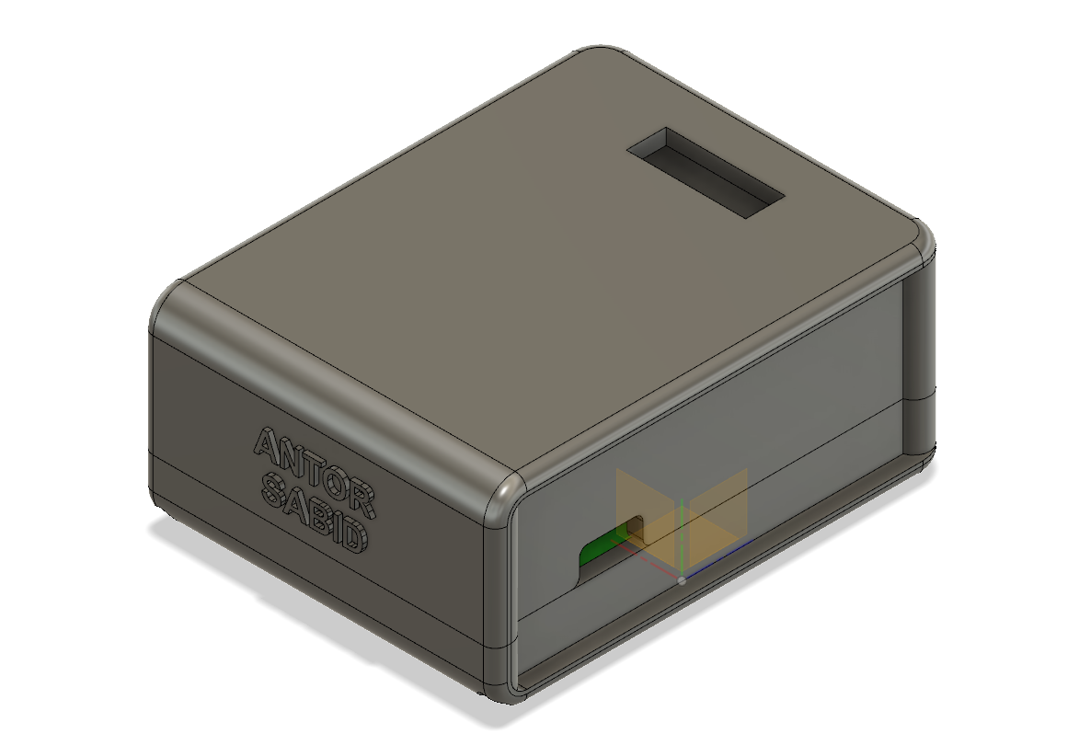
Figure 5.4 3D Model Side View 2
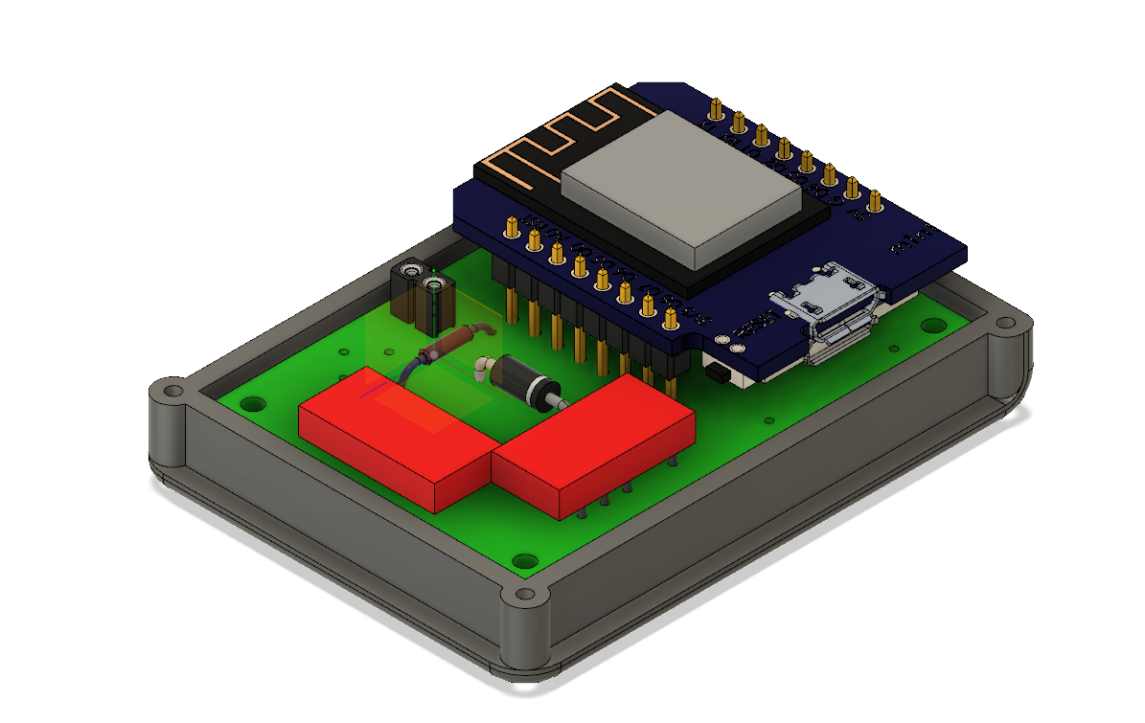
Figure 5.5 3D Model Inside View 1

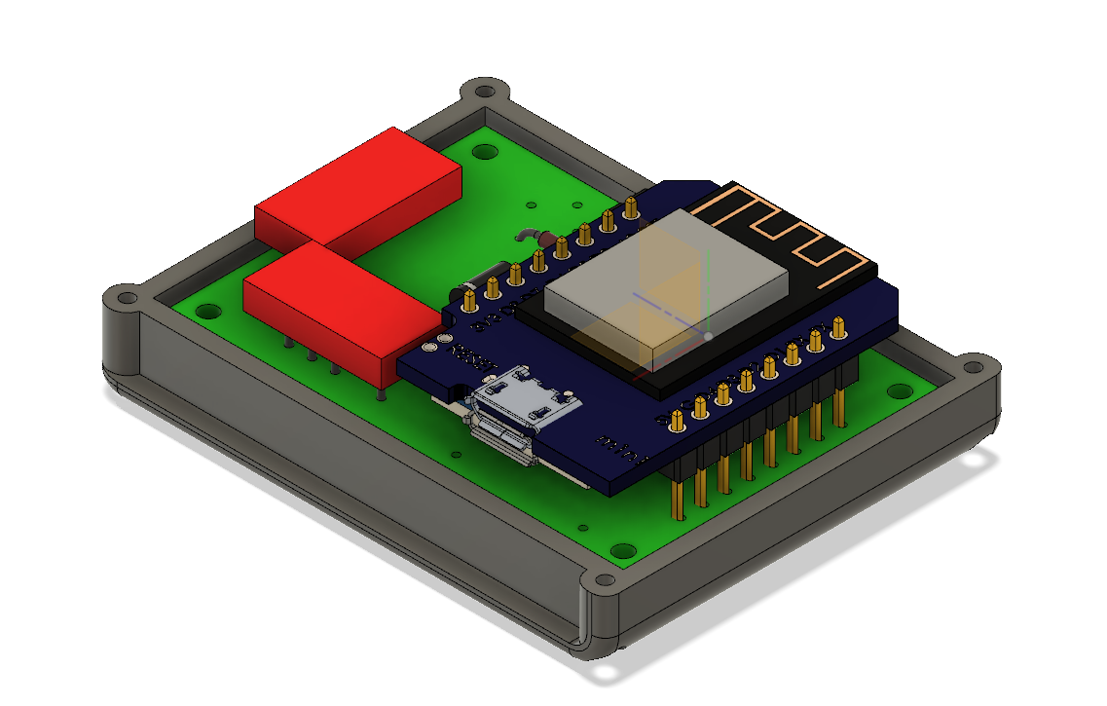
Figure 5.6 3D Model Inside View 2
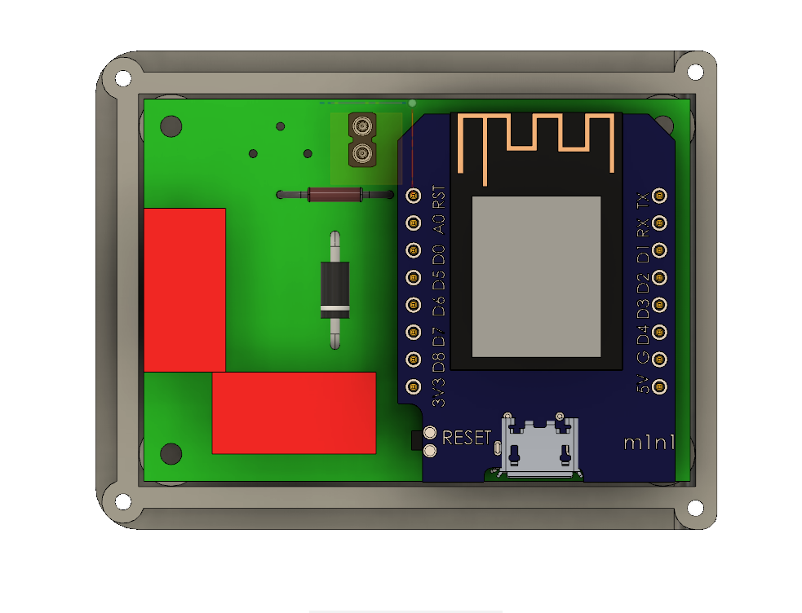
Figure 5.7 3D Model Inside Top View

5.4 Circuit Board Assemble

Assembly follows the component placement and polarity shown in the current schematic and PCB. Before power is applied, inspect solder joints, connector orientation, supply polarity and continuity between VCC and GND.

After assembly, verify the regulated supply and ESP8266 boot behaviour, then test the button, motion input, temperature sensor, LED and buzzer individually. Finally, confirm that device state is exchanged through the API and that a generated Python flow can control the expected outputs.
Record any deviations between the assembled board and the design files, and update the schematic and PCB before producing another revision.

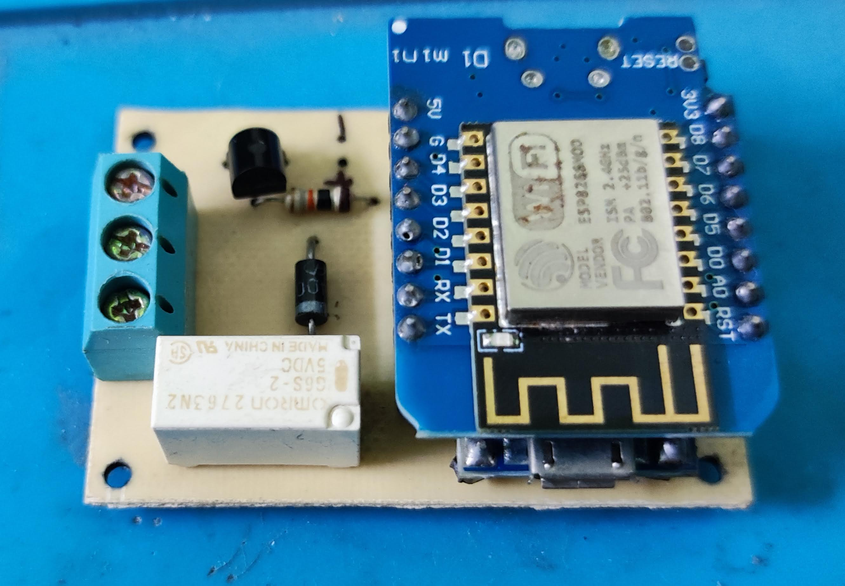
Figure 5.8 Implemented Block - Relay
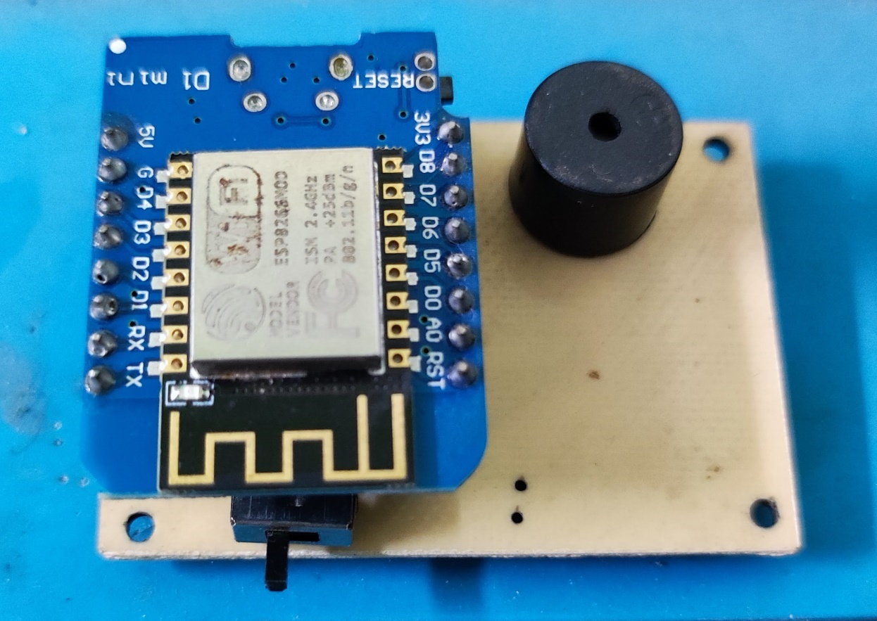
Figure 5.9 Implemented Block – Buzzer

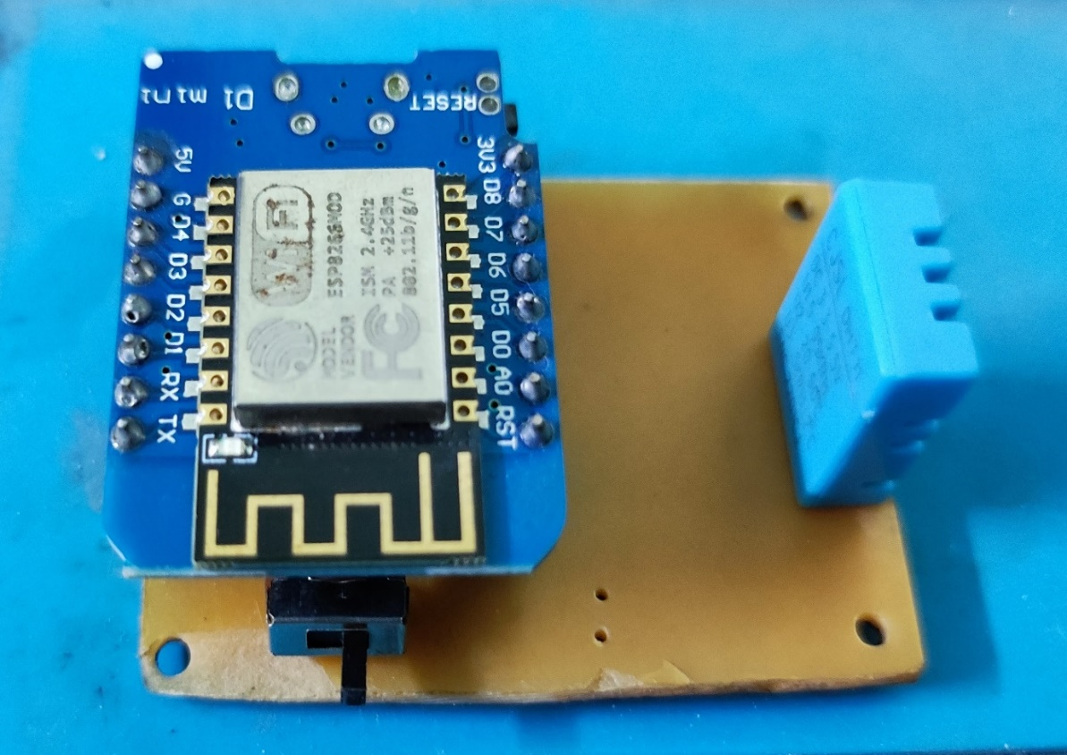
Figure 5.10 Implemented Block - Temperature
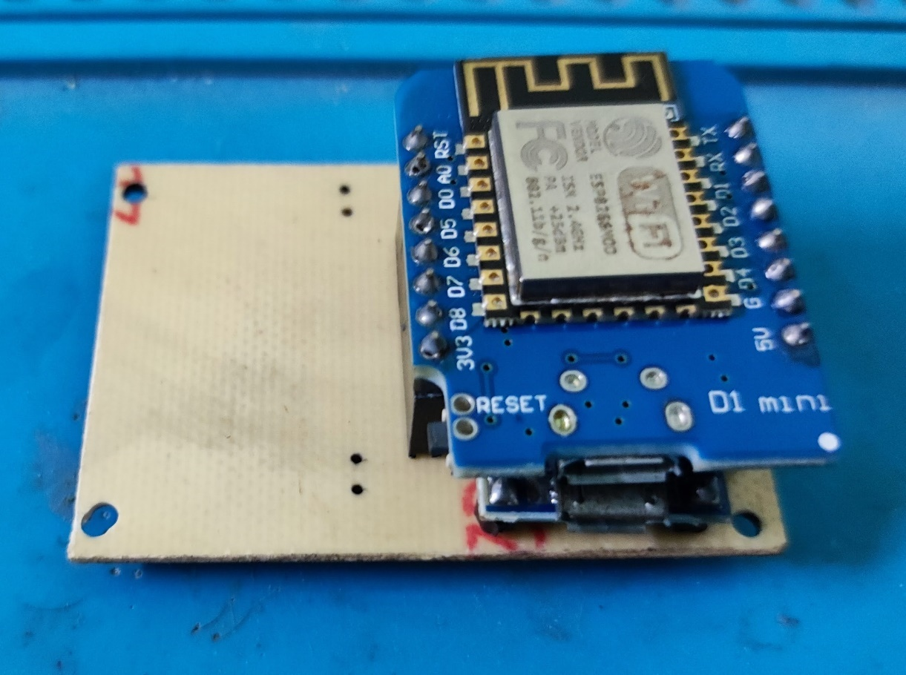
Figure 5.11 Implemented Block - Button or LED

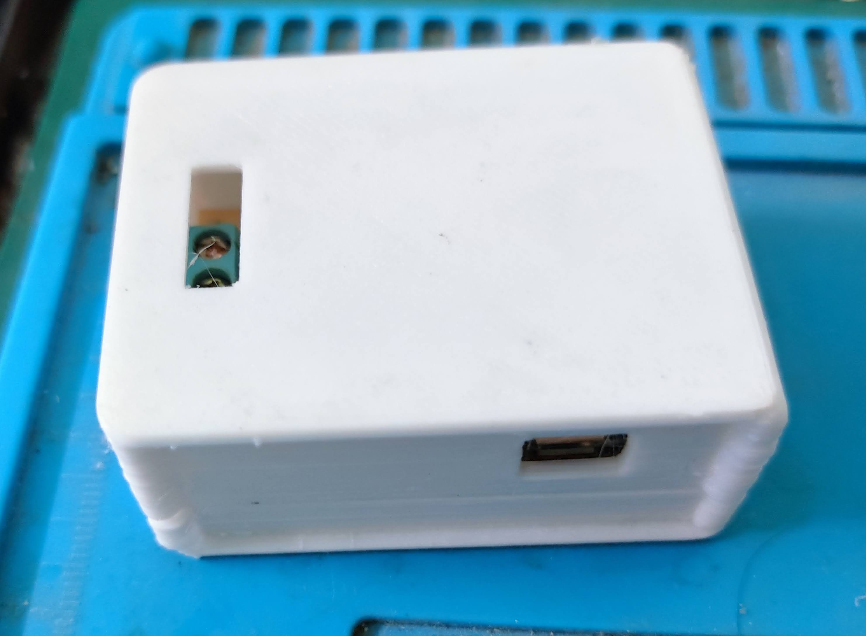
Figure 5.12 Implemented Block - Outside
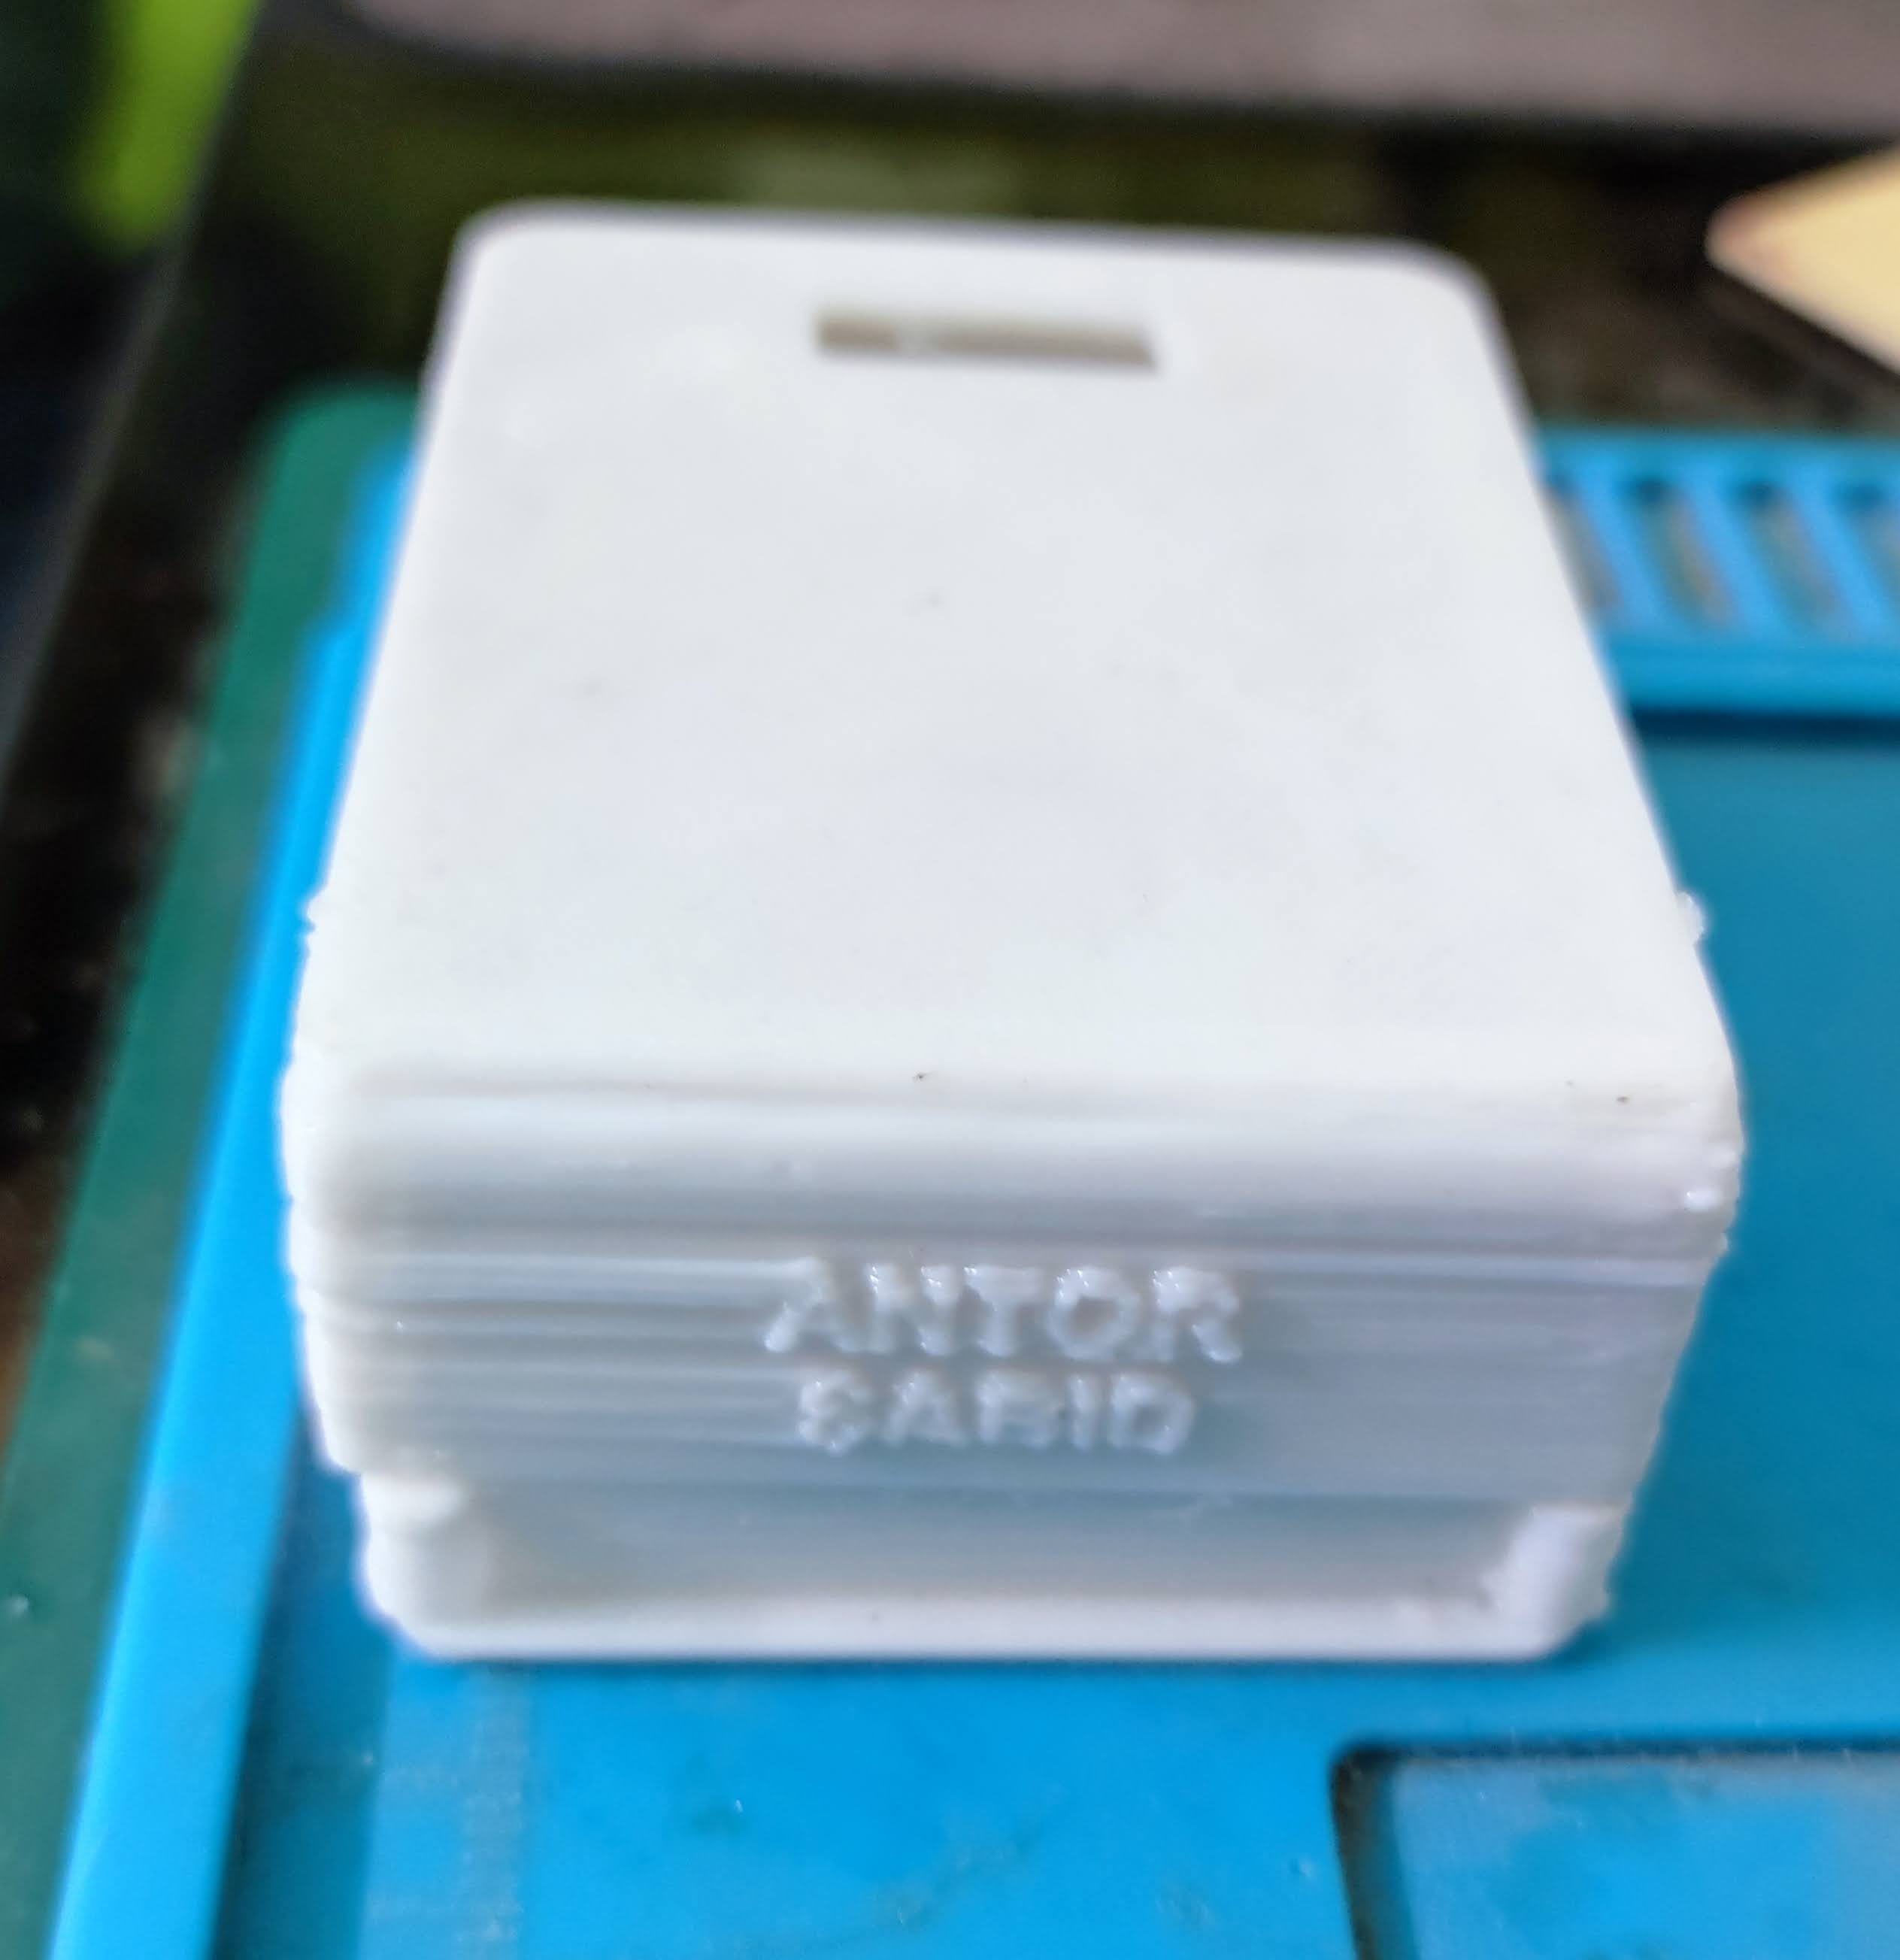
Figure 5.13 Implemented Block - Side View

5.5 Future Works

- Add authentication and authorization to the web application and device API.
- Constrain and audit AI-agent changes, with preview, validation and user approval before a generated script is executed.
- Add version history and rollback for visual flows and generated Python scripts.
- Expand the sensor and actuator catalogue and document electrical limits for each block.
- Evaluate reliability, latency and usability with repeatable hardware and web-platform tests.

5.5.1 Healthcare

In this section, we will see the future of IoT in healthcare sector. IoT has proved to be one of the best tools for the healthcare industry. It helps provide advanced healthcare facilities to patients, doctors, and researchers. These facilities include smart diagnosis, wearable devices for tracking health, patient management, and many more. Furthermore, IoT devices have reduced unnecessary strain on the healthcare system.

5.5.2 IoT in healthcare

The healthcare devices can directly send the patients’ data health to doctors over a safe network. This allows the doctors to diagnose the patients from remote locations.
Reasons for IoT being beneficial in the healthcare industry are as follows:

1. Error reduction in treatments
With the help of IoT devices, there is a decrease in manual errors in diagnosing patients. Thus, patients can get proper treatment on time. Also, the 24/7 diagnosis through gadgets gives a clearer idea about patients’ health when compared to manual diagnosis.
2. Decrease in the cost of treatments
Manual diagnosis requires time and the use of various types of costly equipment, along with other hospital charges. Due to this, the overall cost of the treatment increases. We can reduce these costs by using IoT gadgets. Also, the hospital charges and congestion in hospitals can be reduced as patients can be diagnosed from their respective locations.
3. Availability of specialists in remote locations
Internet of Things solves one of the major problems of the healthcare industry that is the availability of doctors, especially specialists, in remote locations. With the help of IoT devices, the treatment of patients in the physical absence of doctors has become possible. The patients just need to wear the device. Then, the device will send all the real-time data of patients’ health to the respective doctors for analyzing the condition. In this way, the scope of Internet of Things is helping the healthcare sector give proper treatment to the needy.

5.5.3 Agriculture

One of the three basic human needs is food. To fulfill the need for food, we do farming. However, now, as the population of the world is increasing, the agricultural industry is facing many challenges. Also, changes in weather conditions and climate hugely impact the agricultural industry. To meet the rising demand for food, the industry has hence adopted technology to increase productivity. It includes the use of precision farming, agricultural drones, and smart farming applications.

All these are built on top of the application of Internet of Things. Now, let us discuss how precision farming, smart farming applications, and agricultural drones help in increasing the productivity of the land.

5.5.4 Precision farming

In agriculture, Information and Communication Technology is a tool used for smart farming. With the help of IoT-based devices, crop fields are observed. The technology uses sensors to calculate the moisture of soil, humidity, and temperature. Also, it uses an automated irrigation system to make efficient use of water. Precision farming helps farmers monitor their fields and boost productivity.
Agricultural drones
Drones used for agriculture and farming are one of the best applications of Internet of Things. They are used to enhance agricultural processes. We use agricultural drones for planting crops, irrigating fields, spraying of pesticides, and monitoring the fields. With the help of drones, it becomes easier to evaluate the health of crops. This is all possible with the help of smart IoT-based devices that are used to make agricultural drones.

5.5.5 Smart greenhouses

Farmers use greenhouse farming to enhance the productivity of crops. In greenhouse farming, the environmental factors that affect the growth of crops are controlled by manual intervention. However, manually controlling the mechanism for the growth of crops is less productive. The emergence of IoT and technological advancements has led to the creation of IoT-based greenhouses that consist of various devices such as sensors, climate controllers, etc.
These IoT devices help in measuring the various environmental conditions according to the requirements of plants. As all sensors and devices connect over the Internet servers, they provide accurate information on the environmental conditions. Then, the devices activate actuators to control heaters, fans, windows, and lighting of greenhouses to set according to the environment.
This is how the scope of IoT is enhancing the productivity of the agricultural industry.

5.5.6 Automotive Industry

In the 21st century, the application of IoT is revolutionizing the automotive industry. One of the major applications is the creation of self-driving cars that has changed the trends of the automotive industry. Engineers have created self-driving cars to reduce manual errors and ensure a safe drive. Various companies around the world are creating self-driving vehicles including Google, Tesla, Mercedes-Benz, Volvo, Audi, and many more. These self-driving cars use various technologies such as Data Science, Artificial Intelligence, Deep Learning, and IoT. IoT devices are programmed in such a way that they assist in creating an automated system for self-driving cars.

5.5.7 Self-driving cars

These IoT devices consist of HD cameras, thermal sensors, smart navigators, speed controller, rain sensors, wireless connectivity, and proximity sensors. While using these cars, you need to enter your location and the destination. Then, the navigator helps locate the destination and tries to find the shortest path. After that, the IoT-based HD cameras help in getting the visuals of the surrounding and send the data to the AI-based systems. These systems analyze and visualize the data of the surrounding and accordingly fix the response of the self-driving cars. Also, there are IoT-based speed controllers that help regulate the speed of these cars according to the traffic and congestion. This is how the scope of IoT is changing the trends in the automotive industry.

Appendix

PHP API
The PHP API exposes device listing and per-device read/update routes. Requests exchange JSON state, and the checked-in implementation persists each device record in a JSON file. The API validates device identifiers and accepted values before writing state.

Python Automation Runtime
The Python automation runtime consumes device state through the HTTP API and applies the logic represented by the visual designer. The website generates the script from the current flow; the AI chatbot can write or revise the script and apply matching changes to the designer.

ESP8266 Firmware
The ESP8266 firmware is built with PlatformIO and the Arduino framework. It provides Wi-Fi setup, local I/O endpoints and remote state synchronization. Current firmware assignments are D1 for the button, D5 for temperature sensing, D6 for the LED and D7 for the buzzer.

Conclusion
This project brings together a revised ESP8266 programmable block and a web-based automation platform. The hardware design connects sensor and actuator interfaces through an updated schematic and PCB; the PHP API provides device-state exchange; and the React/React Flow designer presents automation as editable connected blocks with generated Python code. The website AI chatbot extends this workflow by writing or revising the script and applying corresponding changes to the visual designer. The result is a prototype that joins physical I/O, visual programming and agent-assisted automation while keeping the resulting flow available for user inspection. Future evaluation should focus on security, controlled execution of generated scripts, electrical validation and repeatable usability testing.

References
- Teymourzadeh, Rozita, et al. "Smart GSM Based Home Automation System." Systems, Process & Control (ICSPC), 2013 IEEE Conference on. IEEE, 2013.

- Singh, Navab, et al. "Remotely controlled home automation system.” Advances in Engineering and Technology Research (ICAETR), 2014 International Conference on. IEEE, 2014.

- Pavithra D,IoT based Monitoring and Control System for Home Automation, Proceedings of 2015 Global Conference on Communication Technologies (GCCT 2015)

- Wenbo, Yan, Wang Quanyu, and Gao Zhenwei. "Smart home implementation based on Internet and WiFi technology." Control Conference (CCC), 2015 34th Chinese. IEEE, 2015.

- Gurek, Alper, et al. "An android based home automation system." High-Capacity Optical Networks and Enabling Technologies (HONET-CNS), 2013 10th International Conference on. IEEE, 2013.

- Beza Negash Getu, Hussain A. Attia, “Automatic Control of Agricultural Pumps Based on Soil Moisture Sensing”, IEEE conference publication, 2015.

- HemlataChanne1, SukheshKothari2, DipaliKadam3, “Multidisciplinary Model for Smart Agriculture using Internet-of-Things (IoT), Sensors, Cloud-Computing, Mobile-Computing & Big-Data Analysis”, International Journal of Int.J. Computer Technology & Applications, Vol 6 (3), May-June 2015.

- Joaquín Gutiérrez, Juan Francisco Villa-Medina, Alejandra Nieto Garibay and Miguel Ángel Porta-Gadara, “Automated Irrigation System Using a Wireless Sensor Network and GPRS Module”, IEEE Transaction on Instrumentation and Measurement, Vol.63, No.1, January 2014.
- Meena Kumari G, Dr. V.Vidya Devi, “Real- Time Automation and Monitoring System for Modernized Agriculture”, International Journal of Review and Research in Applied Sciences and Engineering (IJRRASE) Vol3 No.1. PP 7-12 March 2013.

- Nikhil Agrawal, Smitan Singhal, “Smart Drip Irrigation System using Raspberry pi and Arduino”, International Conference on Computing, Communication and Automation (ICCCA2015)

